Figures and Tables

**Figure 1. HTE system diagram for the entire network. Gray dotted lines indicate components removed for Operation Mercury intervention case (Mo). Black indicates base case (M1), orange is the technological intervention case (MT), blue is the market intervention case (MM), and red is the legal intervention case (ML).**

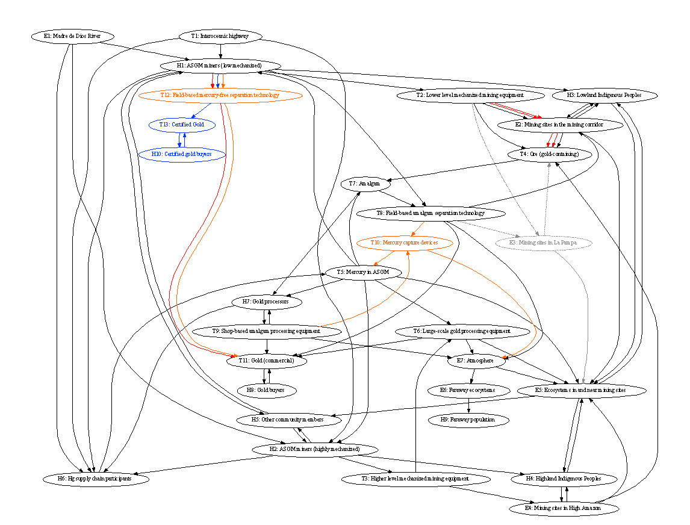

**Table 1. Components used in constructing HTE matrix. Asterisks indicate components not present in base matrix but added in intervention matrices (see Table 2).**

| **Human Components** | **Technical Components** | | **Environmental Components** |
| --- | --- | --- | --- |
| H1. ASGM miners (low mechanized)  H2. ASGM miners (highly mechanized)  H3. Lowland Indigenous  H4. Highland indigenous  H5. Other community members  H6. Hg supply chain participants  H7. Gold processors  H8. Gold buyers  H9. Faraway population  *H10. Certified gold buyers | T1. Interoceanic highway  T2. Lower level mechanized mining equipment  T3. Higher level mechanized mining equipment  T4. Ore (gold-containing)  T5. Mercury used in ASGM  T6. Large-scale gold processing equipment  T7. Amalgam  T8. Field-based amalgam separation technology  T9. Shop-based amalgam processing equipment  *T10. Mercury capture devices  T11. Gold (commercial)  *T12. Field-based mercury-free separation technology  *T13. Certified gold (commercial) | | E1. Madre de Dios River  E2. Lower elevation mining sites inside and outside the corridor  E3. Higher elevation mining sites inside and outside the corridor  E4. Mining sites in High Amazon  E5. Ecosystems in and near mining sites  E6. Faraway ecosystems  E7. Atmosphere |
| **Institutional Components** | | **Knowledge Components** | |
| I1.*Minamata Convention on Mercury  I2. Mercury markets  I3. Gold Markets  I4. Norms and customs surrounding mining  I5. Partnership agreements  I6. South America Infrastructure Initiative  I7. *Formalized mining laws and regulations  I8. *Clean gold certification criteria | | K1. Gold extraction techniques  K2. Health impacts from mercury exposure  K3. Health protection techniques  K4. Mercury concentrations in the environment  K5. Environmental impacts from mercury discharges  *K6. Mercury-free mining practices  *K7. Low-mercury mining practices | |

**Table 2. List of interventions analyzed using the HTE framework.**

| **Name** | **Intervention category** | **Description (intervener)** | **Matrix representation** |
| --- | --- | --- | --- |
| M1 | Base case - no intervention | Base case representation of ASGM system in Madre de Dios |  |
| MO | Physical disruption | Operation Mercury (Peru government) | Removal of component “Mining sites in La Pampa” (E3) |
| MT | Technology-focused | Development and dissemination of mercury capture devices, mercury-free mining methods and locally-targeted capacity building (Outside experts) | New technical components (T10 and T12), knowledge components (K6 and K7), and associated interactions |
| MM | Market-based | Clean gold certification (standard authority) | Building upon MT, added new institutional component (certification standard); new technical component (certified gold); new human components (certified gold buyers) |
| ML | Legal | Minamata Convention (Conference of Parties); Formalization of miners (Peru government) | Building upon MM, added new institutional component “Minamata Convention”; New institutional component reflecting formalized mining laws; additional interactions reflecting Minamata provisions |

Table 3: Analyzed pathways and components relevant to sustainability aspects

| **Selection of analyzed pathways and components** | **Sustainability aspects** |
| --- | --- |
| Pathways between H1/H2 (ASGM miners) and gold buyers (H8/*H10); pathways influencing and centrality measures of gold (T11) | **Livelihood**: ability to earn income and maintain livelihoods |
| Pathways influencing (H3/H4) Indigenous peoples and (H5) other community members; pathways influencing and centrality measures of H1/H2/H3/H4/H5 | **Societal**: impacts on non-mining populations |
| Pathways between mercury used in ASGM (T5) and faraway ecosystems (E6); Pathways influencing and centrality measures of ecosystems in and near mining sites (E5), centrality measures of mercury used in ASGM (T5) | **Environmental**: local and long-range impacts on ecosystems |

Figure 2. Change in centrality measures under Operation Mercury.

Figure 3. Change in Centrality for Combined Technology-Market-Legal Interventions

Figure 4. Change in centrality for intervention cases.

Supplementary Information:

Table S1: Quantitative measures for selected nodes under **base case.** Highest values indicated in red.

| **Component** | **Degree** | **Betweenness** | **# of upstream nodes** | **# of downstream nodes** |
| --- | --- | --- | --- | --- |
| **H1** | 0.310345 | 0.144191 | 21 | 23 |
| **H2** | 0.275862 | 0.073686 | 21 | 23 |
| **H3** | 0.206897 | 0.038342 | 21 | 23 |
| **H4** | 0.172414 | 0.022989 | 21 | 23 |
| **H5** | 0.172414 | 0.149815 | 21 | 23 |
| **T5** | 0.241379 | 0.093103 | 21 | 23 |
| **T11** | 0.172414 | 0.027094 | 23 | 1 |
| **E5** | 0.37931 | 0.2047 | 21 | 23 |
| **E6** | 0.068966 | 0.027094 | 22 | 1 |

Table S2: Quantitative measures for selected nodes under **operation Hg intervention.** Highest values indicated in red.

| **Component** | **Degree** | **Betweenness** | **# of upstream nodes** | **# of downstream nodes** |
| --- | --- | --- | --- | --- |
| **H1** | 0.321429 | 0.134921 | 20 | 22 |
| **H2** | 0.285714 | 0.075463 | 20 | 22 |
| **H3** | 0.214286 | 0.039859 | 20 | 22 |
| **H4** | 0.178571 | 0.023369 | 20 | 22 |
| **H5** | 0.178571 | 0.141777 | 20 | 22 |
| **T5** | 0.25 | 0.096781 | 20 | 22 |
| **T11** | 0.178571 | 0.027778 | 22 | 1 |
| **E5** | 0.357143 | 0.196759 | 20 | 22 |
| **E6** | 0.071429 | 0.027778 | 21 | 1 |

Table S3: Quantitative measures for selected nodes under **technology intervention (network MT).** Highest values indicated in red.

| **Component** | **Degree** | **Betweenness** | **# of upstream nodes** | **# of downstream nodes** |
| --- | --- | --- | --- | --- |
| **H1** | 0.344828 | 0.180357 | 22 | 25 |
| **H2** | 0.275862 | 0.074507 | 22 | 25 |
| **H3** | 0.206897 | 0.038342 | 22 | 25 |
| **H4** | 0.172414 | 0.023912 | 22 | 25 |
| **H5** | 0.172414 | 0.154454 | 22 | 25 |
| **T5** | 0.275862 | 0.136084 | 22 | 25 |
| **T11** | 0.206897 | 0.029557 | 25 | 1 |
| **E5** | 0.37931 | 0.207081 | 22 | 25 |
| **E6** | 0.068966 | 0.028325 | 23 | 1 |

Table S4: Quantitative measures for selected nodes under **market-based+technology intervention.** Highest values indicated in red.

| **Component** | **Degree** | **Betweenness** | **# of upstream nodes** | **# of downstream nodes** |
| --- | --- | --- | --- | --- |
| **H1** | 0.37931 | 0.217303 | 22 | 27 |
| **H2** | 0.275862 | 0.074507 | 22 | 27 |
| **H3** | 0.206897 | 0.038342 | 22 | 27 |
| **H4** | 0.172414 | 0.023912 | 22 | 27 |
| **H5** | 0.172414 | 0.171695 | 22 | 27 |
| **T5** | 0.275862 | 0.145936 | 22 | 27 |
| **T11** | 0.206897 | 0.029557 | 25 | 1 |
| **E5** | 0.37931 | 0.219397 | 22 | 27 |
| **E6** | 0.068966 | 0.028325 | 23 | 1 |

Table S5: Quantitative measures for selected nodes under **legal/market/tech intervention.** Highest values indicated in red.

| **Component** | **Degree** | **Betweenness** | **# of upstream nodes** | **# of downstream nodes** |
| --- | --- | --- | --- | --- |
| **H1** | 0.413793 | 0.217303 | 22 | 27 |
| **H2** | 0.275862 | 0.074507 | 22 | 27 |
| **H3** | 0.206897 | 0.038342 | 22 | 27 |
| **H4** | 0.172414 | 0.023912 | 22 | 27 |
| **H5** | 0.172414 | 0.171695 | 22 | 27 |
| **T5** | 0.275862 | 0.145936 | 22 | 27 |
| **T11** | 0.241379 | 0.029557 | 25 | 1 |
| **E5** | 0.37931 | 0.219397 | 22 | 27 |
| **E6** | 0.068966 | 0.028325 | 23 | 1 |

Table S6. Number of simple paths between pairs of nodes under each intervention (% change)

|  |  | Base | Operation Hg (% change from base) | Tech (% change from base) | Tech+Market (% change from tech) | Tech+Market+Legal (% change from market) |
| --- | --- | --- | --- | --- | --- | --- |
| Livelihood | H1🡪H8 | 200 | 149(-26%) | 378(89%) | 379(0%) | 1177(211%) |
|  | H2🡪H8 | 235 | 183(-22%) | 572(143%) | 611(7%) | 2415(295%) |
| Societal | T5🡪H3 | 176 | 132(-25%) | 214(22%) | 214(0%) | 378(77%) |
|  | T5🡪H4 | 160 | 113(-29%) | 213(33%) | 213(0%) | 453(113%) |
|  | T5🡪H5 | 48 | 36(-25%) | 62(29%) | 62(0%) | 122(97%) |
|  | H1🡪H3 | 105 | 73(-30%) | 206(96%) | 206(0%) | 516(150%) |
|  | H1🡪H4 | 230 | 161(-30%) | 457(99%) | 457(0%) | 1175(157%) |
|  | H1🡪H5 | 111 | 77(-31%) | 246(122%) | 246(0%) | 672(173%) |
|  | H2🡪H3 | 207 | 156(-25%) | 280(35%) | 280(0%) | 536(91%) |
|  | H2🡪H4 | 103 | 73(-29%) | 170(65%) | 170(0%) | 402(136%) |
|  | H2🡪H5 | 54 | 42(-22%) | 80(48%) | 80(0%) | 176(120%) |
| Environmental | T5🡪E5 | 82 | 59(-28%) | 107(30%) | 107(0%) | 227(112%) |
|  | T5🡪E6 | 159 | 117(-26%) | 291(83%) | 291(0%) | 823(183%) |
|  | E5🡪H3 | 23 | 19(-17%) | 23(0%) | 23(0%) | 31(35%) |
|  | E5🡪H4 | 21 | 17(-19%) | 51(143%) | 51(0%) | 143(180%) |
|  | E5🡪H5 | 3 | 3(0%) | 7(133%) | 7(0%) | 19(171%) |

Figure S1. Centrality change for technical interventions

Figure S2. Market interventions centrality change (change in centrality MM-MT)

Figure S3. Legal interventions centrality change (change in centrality ML-MM)

